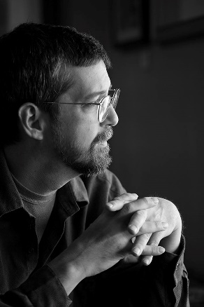

**Jonathan Bock**

Jonathan Bock is a career artist and gallery owner, with a lifetime passion for the arts.  He is owner of Williams Gallery West, specializing in American and international fine art and folk art; and Stellar Gallery, specializing in Fine Art Photography. He is president and founding director of *Sierra Art Trails*, a California non-profit organization dedicated to promoting working artists and artisans in the Sierra Foothills, and executive director of the non-profit organization *Yosemite Renaissance*, dedicated to promoting the arts in Yosemite National Park and the California Sierra Nevada region.

Bock is an experienced curator and art director. He has managed, curated, judged, and juried dozens of exhibits, and has worked with hundreds of contemporary artists, as well as exhibiting his own work.

His artwork includes drawing, painting, printmaking, photography, ceramics, experimental film and video, animation, and interactive media.  Bock is particularly at home behind the camera and at the computer. His photographic and computer experience extends from darkroom printing in the 1960s to contemporary digital processes.

Bock's galleries offer appraisal and consignment services for art and antiques. His extensive knowledge of important artists, historical periods and styles, and trends in the art world are invaluable assets required to determine the importance and value of various works, and to understand the needs of clients and collectors.

Education - BFA degree in printmaking and art history from Indiana University, Bloomington (1984), and an MFA degree with a focus on experimental animation from California Institute of the Arts (1989).

**Williams Gallery West is located at**

**40982 Highway 41, Oakhurst, CA 93644, Telephone 559-683-5551**

**Web Site:** [**www.galwest.com**](http://www.galwest.com) **Email: info@galwest.com**