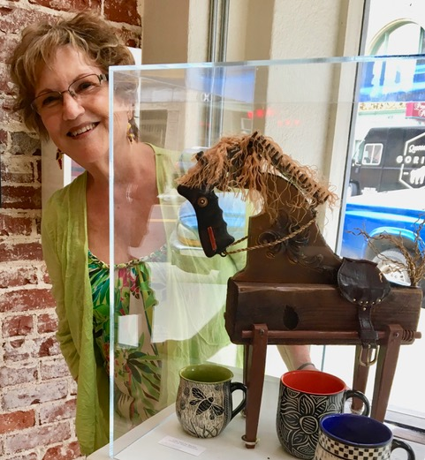
Myrna Axt – Mixed Media Assemblage

Driven by a childlike curiosity, and a love for objects and collections, Myrna Axt found her creative voice as a mixed media artist at age 65.

“There is a cycle of life...Birth, Growth, Death, Decay, and Rebirth....that’s where I come in. I take communion at my worktable with a desire to open a door, without knowing where that door leads. I stand back, and let MY IMAGINATION TAKE FLIGHT. My eyes travel over my accumulation of ‘finds’ and MY SOUL SINGS! Common items once used for one purpose are now moving in new directions... I wonder, who has touched these? Who and how was this remnant used? I like to think that part of that person’s energy is still contained within the object and grants me new creative powers.”

There is something magical about taking an ordinary, or dilapidated object, and reviving it into something extraordinary. This is Myrna’s belief and goal in all her 3-dimensional, found object compositions. She is passionate about engaging her hand and heart by intuitively breathing life into discarded remnants, so these can be appreciated in new ways and shared with others.

Myrna’s desire is to do the unexpected and uplift reality using individual pieces that were never intended to be together. In her work, she is constantly seeking synergy between the “known” quantity, the core value of a piece, and still paying homage to the subtlety of the composition.

Works by Myrna Axt are available through Williams Gallery West
http://www.galwest.com
40982 Hwy 41, Suite 3, Oakhurst, CA 93644
559-683-5551

